**11.Create table given below: Salesperson and Customer**

**TABLE 1 :**

CREATE TABLE SALESPERSON(

SNO INT PRIMARY KEY,

SNAME VARCHAR(20),

CITY VARCHAR(30),

COMM DECIMAL(4,2)

);

INSERT INTO SALESPERSON VALUES(1001, "PEEL", "LONDON", 0.12),

(1002, "SERRES", "SAN JOSE", 0.13),

(1004, "MOTIKA", "LONDON", 0.11),

(1007, "RAFKIN", "BARCELONA", 0.15),

(1003, "AXELROD", "NEW YORK", 0.1);

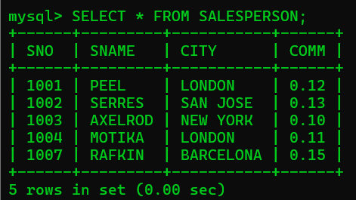

**Table 2 : CUSTOMER**

CREATE TABLE CUSTOMER(

CNO INT PRIMARY KEY,

CNAME VARCHAR(50),

CITY VARCHAR(50),

RATING INT,

SNO INT,

FOREIGN KEY(SNO) REFERENCES SALESPERSON (SNO)

);

INSERT INTO CUSTOMER VALUES(201, "HOFFMAN", "LONDON", 100, 1001),

(202, "GIOVANNE", "ROE", 200, 1003),

(203, "LIU", "SAN JOSE", 300, 1002),

(204, "GRASS", "BARCELONA", 100, 1002),

(206, "CLEMENS", "LONDON", 300, 1007),

(207, "PEREIRA", "ROE", 100, 1004);

